State of the art for SemEval 2026 Task 2

- Background

Affect refers to the broad psychological construct encompassing moods, feelings, and emotional states. In computational affective science, affect is commonly represented using the valence–arousal (V&A) space, where valence denotes emotional pleasantness (negative → positive) and arousal reflects physiological activation (calm → excited). This representation, rooted in Russell’s Circumplex Model [Fig. 1], captures subtle emotional nuances that categorical labels (e.g., anger, joy) cannot.

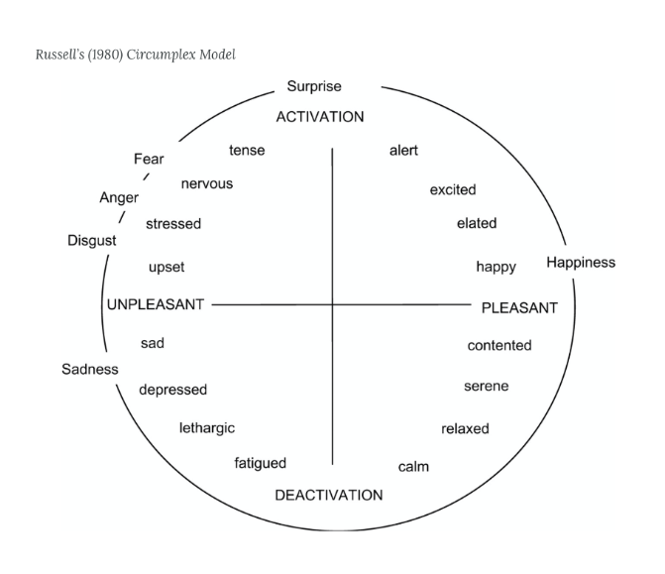Fig. 1

Recent work has emphasized the benefits of dimensional emotion modeling. Takanami and El-Haj (2023) [1] demonstrate that diverse emotional datasets can be unified in the VAD space, reinforcing valence and arousal as stable, interpretable dimensions across domains.

The SemEval-2026 Task 2 dataset consists of 5,285 longitudinal texts, collected from 182 users over a multi-year span (2021–2024). Each observation is a pairing of a written text and a self-reported emotional state, represented in the valence–arousal (V&A) space. Because these texts were written in real time as part of Ecological Momentary Assessment (EMA), the dataset captures authentic, naturally occurring emotional expression rather than laboratory-elicited responses. This property makes the dataset considerably more challenging than typical sentiment or emotion corpora.
Each user contributes a sequence of texts — either ecological essays (free-form descriptions of how they are feeling) or feeling words (e.g., happy, calm, tired, frustrated). The presence of these two genres is important. Essays provide rich linguistic and syntactic information, whereas feeling words function as concise emotional self-labels.
In many emotion-analysis datasets, emotional labels are produced through trained human annotators, whose judgments are later reconciled using agreement metrics or fusion procedures. For example, in the multilingual emotion corpus by Muhammad et al. (2025)[2], final labels are derived by comparing the opinions of several annotators and applying rules such as requiring at least two annotators to agree on an emotion and using averaged intensity thresholds to determine the final label.
Similarly, in the narrative emotion dataset by Alm (2008)[3], later extended in recent work, annotations are obtained from multiple annotators and merged through reliability-based fusion methods such as the Evaluator-Weighted Estimator (EWE).
Together, these factors imply that the current dataset likely contains natural anomalies, irregular emotional patterns, and user-specific baselines that models must learn to handle. Rather than reflecting annotation disagreement, these anomalies reflect genuine psychological and behavioral variation in how different individuals perceive and articulate their emotional states.

- Problem definition
Subtask 1 frames affect estimation as a regression problem. Given a sequence of texts written by a user:
e_1, e_2, …, e_m
the goal is to predict a corresponding sequence of real-valued valence–arousal pairs:
(v_1, a_1), (v_2, a_2), … , (v_m, a_m)
The inputs include:
- user_id: anonymized identifier for the writer
- text_id: unique identifier per entry
- text: either a free-form essay or a short feeling-word set
- timestamp: submission time, determining chronological order
- collection_phase: phase label (1–7) capturing the multi-year collection window
- is_words: boolean flag distinguishing feeling-words from essays
- valence, arousal: ordinal labels representing affect
The central challenge in Subtask 1 is to infer emotional meaning from heterogeneous textual input while accounting for individual variation in emotional expression. Essays may include descriptions of daily events, metaphors, or reflections, while feeling-words provide highly compressed affective cues. Models must learn to map both formats reliably into valence–arousal space.

For Subtask 2, the dataset contains all the columns from Subtask 1 (user_id, text_id, text, timestamp, collection_phase, is_words, valence, arousal), with the addition of two derived fields—state_change_valence and state_change_arousal—which quantify the moment-to-moment change in a user’s affect between consecutive texts.
In Subtask 2A, For each text in a user’s timeline, the goal is to predict:
Δ1(v)=vt+1−vt
Δ1(a)=at+1−at
These labels measure short-term emotional shifts—how much valence and arousal are expected to increase or decrease after the next entry. The temporal ordering is strictly determined by timestamps. The final entry for each user receives no label (NaN), as no subsequent text exists.
This task requires models to capture immediate emotional momentum, sensitivity to contextual cues, and fluctuations in user mood. Importantly, predictions are continuous-valued floats, even though the underlying labels arise from ordinal annotations.
Subtask 2B examines long-term affective drift rather than moment-to-moment fluctuation. For each user, the sequence is divided into two halves:
- Group 1: the first half of texts
- Group 2: the second half
The dispositional change in valence is computed as:

Δavg(v)=mean(vgroup 2)−mean(vgroup 1)
Δavg(a)=mean(agroup 2)−mean(agroup 1)

The task is to predict these long-term changes using only the texts in Group 1.

- Related work
Automatic prediction of affective dimensions such as valence and arousal from text has long been a core research problem in affective computing. One approach relies on affective lexicons [5], but these it struggles to capture the contextual and stylistic complexity of natural language.
Deep learning methods, especially those emerging from past SemEval tasks, significantly improved performance. For example, the NTUA-SLP system (SemEval-2018 Task 1) [4] used a BiLSTM architecture with self-attention, demonstrating that neural sequence models can effectively learn emotional cues from text without manually engineered features. This marked the transition from lexicon-based to representation-learning–based emotion modeling.
More recently, Transformer-based architectures have become the dominant paradigm. Mendes & Martins (2023) [3] show that multilingual pre-trained Transformers achieve state-of-the-art results on valence–arousal prediction across several datasets. Their work confirms that contextualized embeddings capture subtle variations in emotional tone more effectively than recurrent networks or lexicon-based systems. This aligns with findings from narrative emotion studies such as those presented in the DENS-style annotation work, which highlights reliability challenges and the need for robust semantic representations in long-form emotional text.
Although forecasting future emotional states from text remains relatively underexplored, several recent studies provide methodological foundations that are relevant to Subtask 2. Research on temporal mental-health prediction shows that a user’s historical language patterns can be used to model and forecast future affective outcomes. For instance, Shen et al. (2025)[6] demonstrate that combining textual embeddings with temporal architectures such as LSTMs and Transformers enables accurate prediction of future depressive severity from longitudinal social-media posts. Similarly, A.Manikandan et al. (2025) [7] propose Deep MoodSense, an RNN-based forecasting framework trained on sequences of self-reported mood entries, showing that recurrent models can effectively capture mood fluctuations and anticipate future emotional states. A complementary line of work by Liu et al. (2025) [8] introduces a two-stage pipeline for longitudinal sentiment analysis in conversational data, where per-utterance sentiment is first extracted and then modeled over time using statistical trajectory methods. Although these studies do not operate on valence–arousal annotations or ecological essays, they collectively demonstrate that emotional trajectories can be learned from sequential text data. These findings provide conceptual support for the forecasting challenges in Subtask 2, which requires predicting both short-term state change (Δ₁) and longer-term dispositional drift (Δavg) from users’ longitudinal emotional narratives.

